

Via Fax: (573)751-8115
Mr. Joshua Cox
Missouri Department of Revenue
General Counsel’s Office
Post Office Box 475
Jefferson City, Missouri 65105-0475

RE: Petitioner: Haley Jones
Docket No.: JEFF0090
Case No.: AD24007882
DLN: D127212001
Hearing Date: November 6th, 2024

Dear Mr. Cox:

Petitioner would like the Hearing Officer to review the documents on file with the Department of Revenue and make a decision based on these documents, having no additional evidence to submit.

Please call me right away if there is an issue with this request or if you should have any questions. Thank you for your assistance and your courtesy.

Sincerely,

John C. Schleiffarth #63222
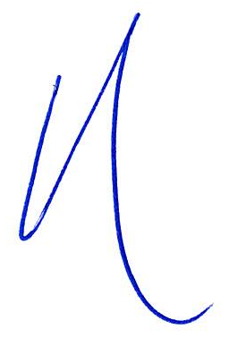
_/s/John Schleiffarth__________________
John C. Schleiffarth #63222
120 S Central Avenue, Suite 1550
Clayton, Missouri 63105
Telephone: 314-561-9690
Facsimile: 314-596-0658
Email: john@jcsattorney.com
Attorney for Petitioner
JCS/taw
facsimile

